**Top 5 benefits you need to know about airbrush makeup**

Every actor and actress's best kept secret is the [airbrush makeup](https://cmcoctober2023.in/surya).Nowadays makeup is a normal thing in everyday life.In every occasion makeup is the first priority that is given by everyone. Most people like to wear natural and flawless makeup.

Airbrush makeup a new technology for the [flawless makeup](https://www.ndtv.com/shopping/5-long-lasting-foundations-that-will-give-you-a-flawless-finish-this-festive-season-4319046).In this the foundation is applying by spraying instead of finger or sponge.It uses compressed air and mist foundation over the skin with the help of controlled air compressor gun.So each portion of the face can apply correct layer of foundation.It is durable and last for 6-10 hours.Hence you can make your special events special and unique by opting airbrush makeup.

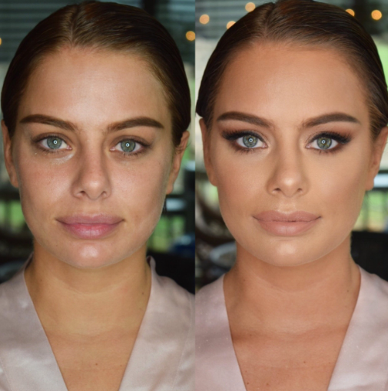

**Benefits of Airbrush Makeup**

* Flawless Makeup

Using airbrush makeup you will get a flawless and natural makeup.It’s spraying technology will give an even texture in the face by hiding your scars,under eye circle etc.It will avoid skin look cakey or unnatural.

* Durability

Airbrush makeup will last at least for 6-10 hours.For bridals this is the right choice for making their event great.

* Suitable for all skin types

Airbrush makeup is suitable for oily,dry and sensitive skin types.Also it is waterproof.

* Easy for application

Airbrush makeup is easy to apply because of its spray technology by ignoring scars ,acne etc.

* More coverage

[Airbrush makeup](https://cmcoctober2023.in/surya/services) gives more coverage with less product.So if you are a person who loves less product with more coverage you can choose airbrush makeup.

**Conclusion**

Airbrush makeup gives you a perfect makeup with a flawless look.Choose airbrush makeup done by the experienced staff of [Surya Makeover Studio](https://cmcoctober2023.in/surya/) and get your complete outlook on your big day and also for special occasions. Look at some of our clients' [experiences](https://docs.google.com/document/d/1DhRdddePieA4VmaR9n9NiMJNFJt1td8Y4kd7JVJf8Y4/edit).